**DSA Assignment - 17 June**

Name – Shwetank Tripathi

Roll.No - 22/11/EE/038

LeetCode Id – dumbledore_001

GeekforGeeks – dumbledore_001

Github Repo Link - /Shwetank-Tripathi/Practice

DSA- Section -

Question 1: Reverse digits

Platform: GeeksforGeeks

Problem Link: https://www.geeksforgeeks.org/problems/reverse-digits/1

Submission Screenshot:

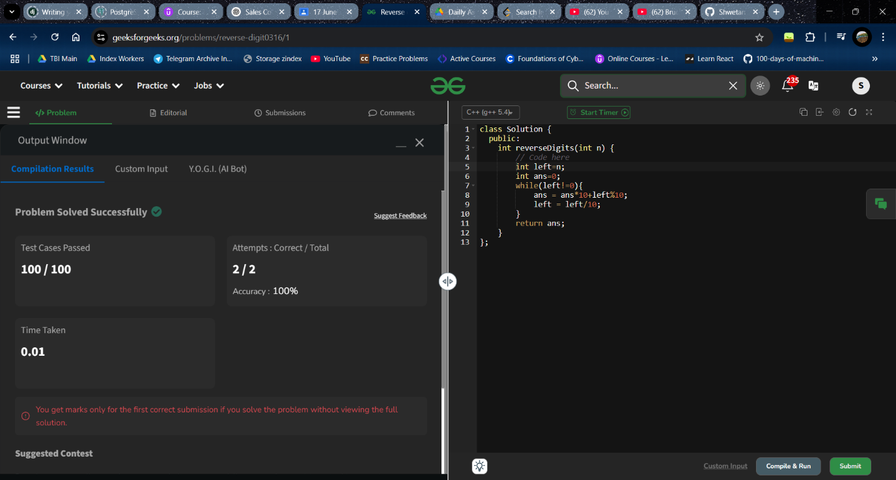

Question 2: Search Insert Position

Platform: LeetCode

Problem Link: https://leetcode.com/problems/search-insert-position/

Submission Screenshot: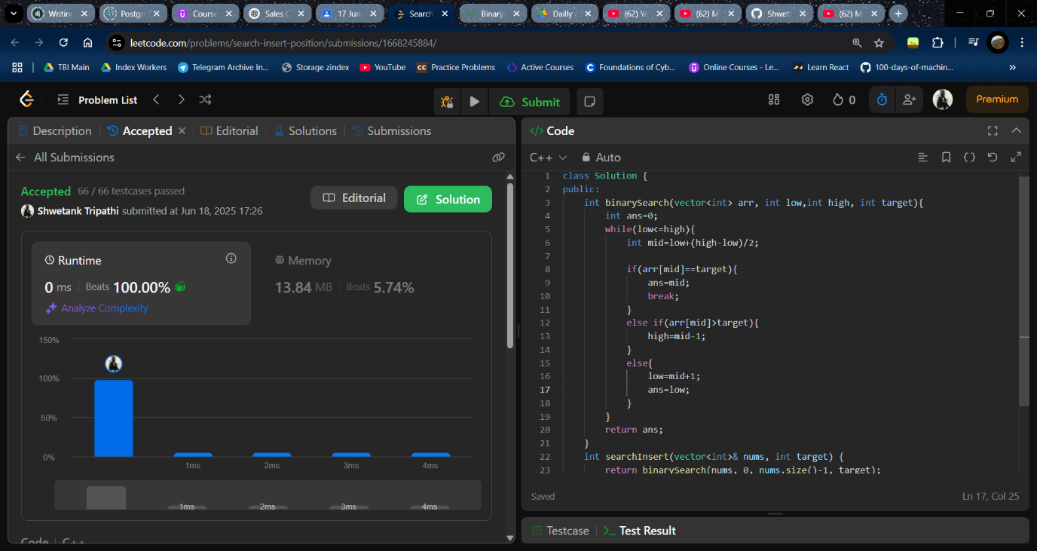

Question 3: Single Number

Platform: LeetCode

Problem Link: https://leetcode.com/problems/single-number/

Submission Screenshot:

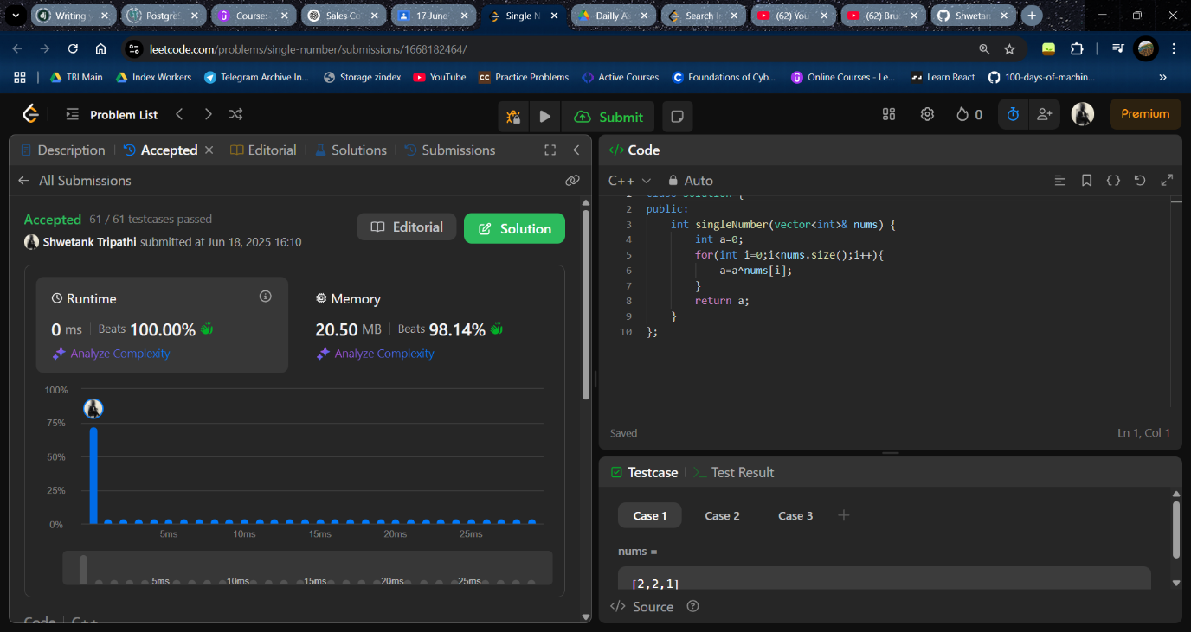

Question 4: Missing Number

Platform: LeetCode

Link: <https://leetcode.com/problems/missing-number/description/>

Submission Screenshot:

